GUIDELINES FOR THE SUBMISSION OF THE FINAL PAPER

Before submission, please check:
One author has been designated as the corresponding author with contact details:
• Affiliation
• ORCID ID
• Email address
• All figures (include relevant captions)
• All tables (including titles, description, footnotes)
• Manuscript has been 'spell checked' and 'grammar checked'
• All references mentioned in the Reference List are cited in the text, and vice versa
• Permission has been obtained for use of copyrighted material from other sources (including the Internet)
• Relevant declarations of interest have been made
• Referees suggestions, if any, were addressed.

TITLE
(TIMES NEW ROMAN, 14 FONT SIZE, BOLD, ALL CAPS, CENTERED)

Author’s Name and Surname¹,Author’s Name and Surname^{2,} (12 font size)
¹Affiliation, ORCID ID, Email, ²Affiliation, ORCID ID, Email

Abstract: Abstract should be written with 10 font size, Times New Roman, single line spacing. Summarize in this section objective, method and findings/conclusions. If the paper is not written in English, an English version of the abstract must also be included.

Keywords: This section should contain maximum 5 words separated by commas. If the paper is not written in English, an English version of the keywords must also be included.

GENERAL GUIDELINES
The final paper must contain the following sections: abstract and keywords, introduction, methodology, findings, conclusion, and references. Section can be named differently and subsections can be included.

The final paper shall be written in font Time New Roman, single line spacing and 11 font size. The final paper should contain a minimum of 3000 words and a maximum of 4000 words. The final paper can contain figures, tables and/or images which are not included in the word count. The references are not included in the word count as well. Page format should be A4 page size with margins 2.5 cm wide from the right, left, top and bottom. Pages should not be numbered. No headers and footers should be included in the document.
Supporting figures, tables and images of the results (no more than four figures and four tables) may be included. Editorial constraints may have to be applied.
All the tables, images and figures should be centered. Figures and images should be numbered (see Figure 2 for an example) and figure headers should be placed under the figure or image; as for the tables, they should also be numbered (see Table 2 for an example) and the table header should be placed at the top. References (if any) of the tables, figures and images should be presented right under the tables, figures and images in the form of author surname and publication date.

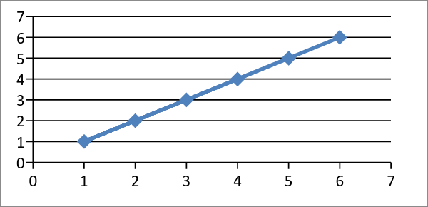

Figure 2. Header

Table 2. Header
Reference: author surname and publication date

INTRODUCTION (Times New Roman, 14 font size, bold, all caps)
The introduction section should (1) present the scope and objective of the paper and state the problem, (2) briefly review the pertinent literature, (3) describe the methods, and (4) provide an overview of the main results of the work.

METHODOLOGY
The methodology must be clearly stated and described in sufficient detail or with sufficient references. The author shall explain the research question, describe the research framework, and the methods applied in detail. It should be furthermore highlighted why the research question is relevant to theory and practice, and why the chosen method(s) are suited for the problem.

FINDINGS
The arguments and findings are described in detail in this section.

CONCLUSIONS
Conclusions should include (1) the principles and generalisations inferred from the results, (2) any exceptions, problems or limitations of the work, (3) theoretical and/or practical implications of the work, and (5) conclusions drawn and recommendations.

REFERENCES
References should be listed in alphabetical order and presented in a format according to the APA Manual of Style 6th edition: http://www.apastyle.org/manual/

